POI 17:

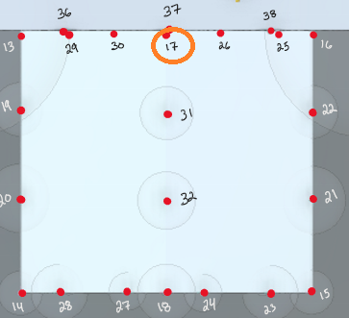

Should pull FQN **@Ron Geyer**

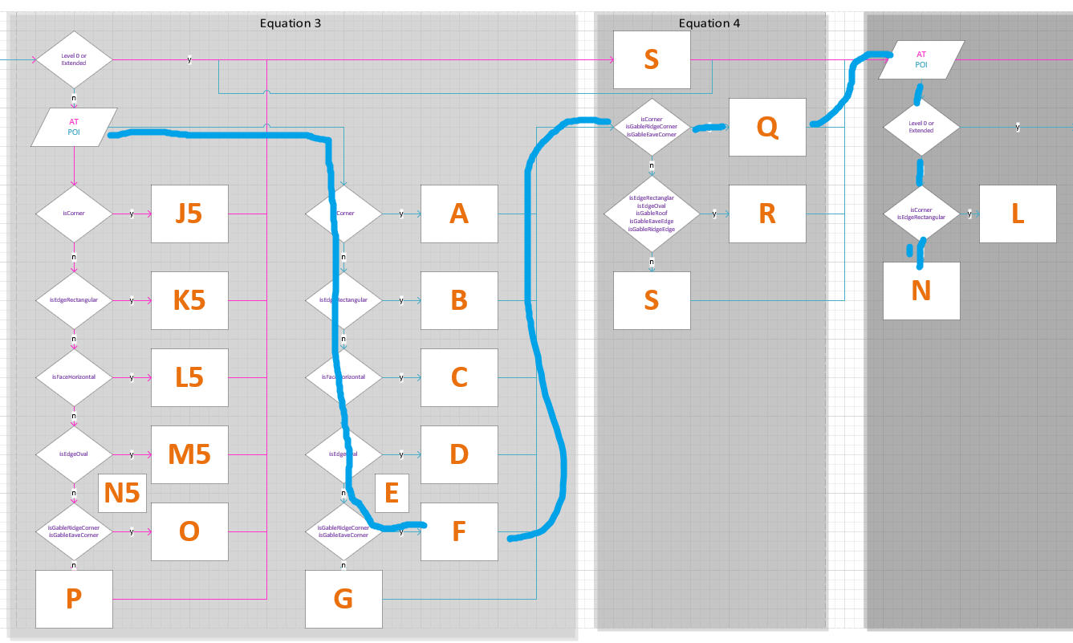

POI 25-26:

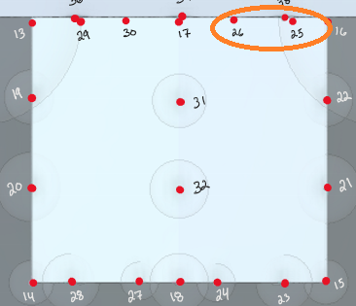

Should pull GRN **@Ron Geyer**

POI 29-30:

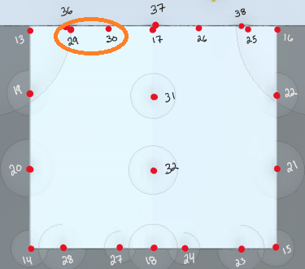

Should pull GRN **@Ron Geyer**

POI 36-38:

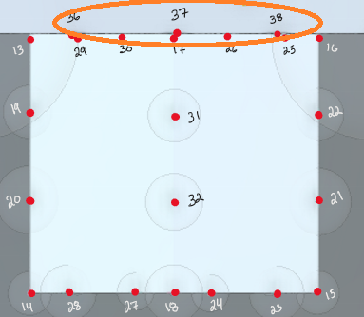

Should pull GRN **@Ron Geyer**

POI 59- 65:

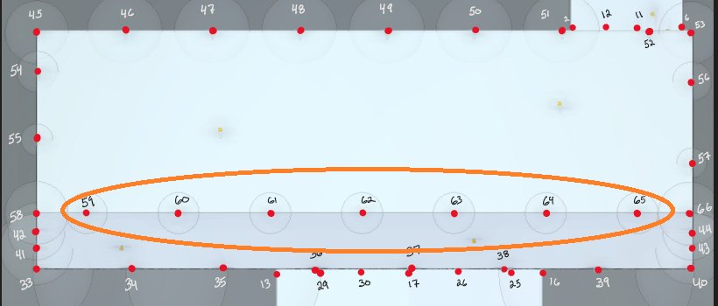

Should pull GRN **@Ron Geyer**

POI MAP:

